Document References

All Document References in Visual start in Document Maintenance where you set up a “Document Id” for the document and select a location where this document can be found.

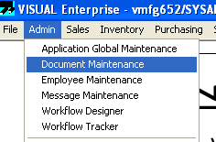

You will most likely have a file storage area for all your documentation, drawings, specification sheets, etc.

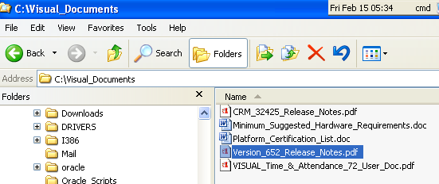

In Document Maintenance, you set up your document Id, path to the document, revision, reference type, document category.

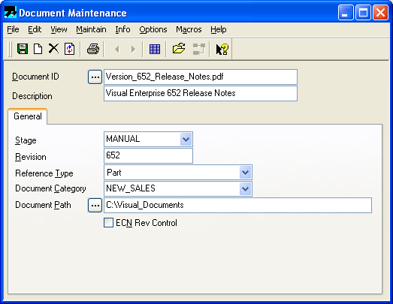
If you want certain documentation to “follow” a part, you can assign a document to a part id.

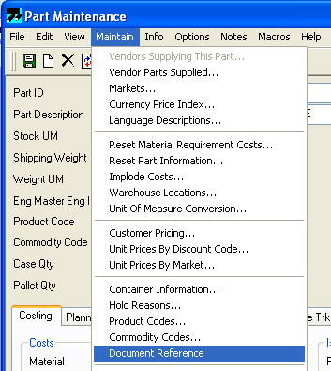

In here you can choose the documents you want for this part id.

